Kitten FAQs

**How can I track my habits through Kitten?**

Kitten is a program that tracks and records a variety of user habits on a computer. It can track how long you spend on a website or application, your mouse movements and mouse clicks, as well as key presses. It allows you to set preferences and settings for how the application and device data should be recorded and presented.

**What types of habits does Kitten track?**

Kitten allows you track several different habits, including mouse movements, mouse clicks, keyboard usage, time spent on applications, and time spent on websites.

**Can I save the data that Kitten records after I end a tracking session?**

Yes. Kitten allows you to download the data from your session so that you can track your habits. You can click “Download Data” in any of the data tracking tabs labeled “Mouse”, “Keyboard”, “Websites”, and “Programs”.

**How can I monitor my habits over a long period of time?**

Kitten allows you to save all your habit tracking data so that you can oversee your habits from any session that you tracked. You can retrieve this data at any time and use it to compare the different times that Kitten tracked your application habits.

**How can I reset a tracking session?**

You just need to click “Stop Tracking Data” to end your current session and then click “Start Tracking Data” in the tab labeled “Data Select” to reset the tracking session.

**If I do not want Kitten to track all habits, can I choose to only track select habits?**

Yes. In the “Data Select” tab, you can choose what specific habits that you would like Kitten to track. You may, for example, want to only track mouse movements and not mouse clicks and Kitten will allow you to specifically select what you want to be tracked.

**How can I view the progress of the habits that Kitten has tracked?**

After you have selected what habits you would like Kitten to track and pressed “Start Tracking Data” in the tab “Data Select”, select any of the following habit tabs, ““Mouse”, “Keyboard”, “Websites”, and “Programs”. There, you can click on “Visualize Data” to see what data Kitten has collected about your habits on a computer.

**Can I choose to track my habits on a specific website or application?**

Kitten will allow you to track the time spent on a specific website or application of your choice, but to track mouse or keyboard data on just one specific website or application, you must only have that website/application running during the tracking session.

**Is there a way for me to set a timer on Kitten to automatically track my habits for a specified period?**

We do not offer this is an option on Kitten. Kitten was created to accurately track and record users’ habits on a computer, therefore we would like the user to provide their start and end time of activity. Timers may limit the amount of data collected while tracking habits if users still engage in habits being tracked even after a set timer is up.

Graph Explanations

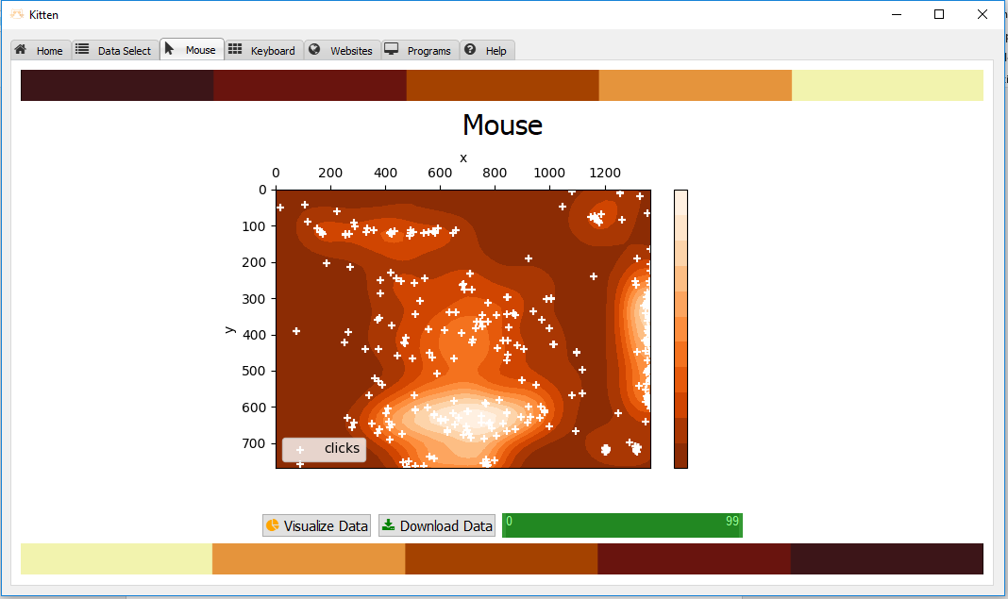

This is a heatmap of the data collected from the mouse clicks and mouse movements of a user. The white icons  denote mouse clicks, and they are generally spread across the areas of higher mouse movements. The lighter the area, the more mouse movements in that specific area. As seen in the graph, the user has far fewer mouse clicks in the corners than toward the center.

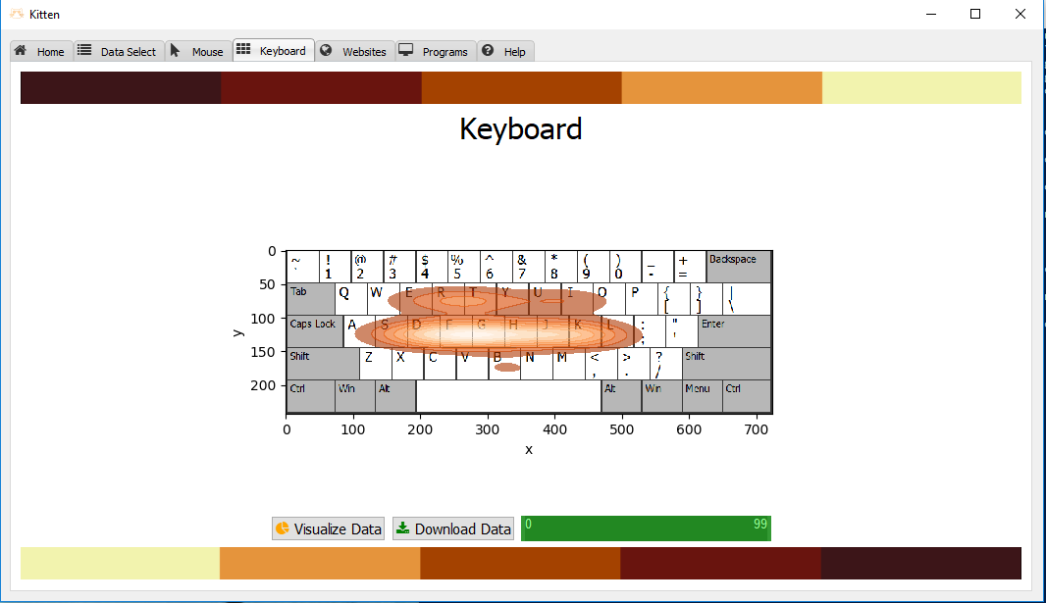

This is a representation of the frequency of used keys on a keyboard, with darker shades showing keys less used than keys shown in brighter colors. The concentration of color in the middle of the graph shows that those keys are somewhat used and the lighter shades within that concentration denote the most popular keys that the user presses. Keys outside of the dark concentration of color were not used.